YOUR
Dream

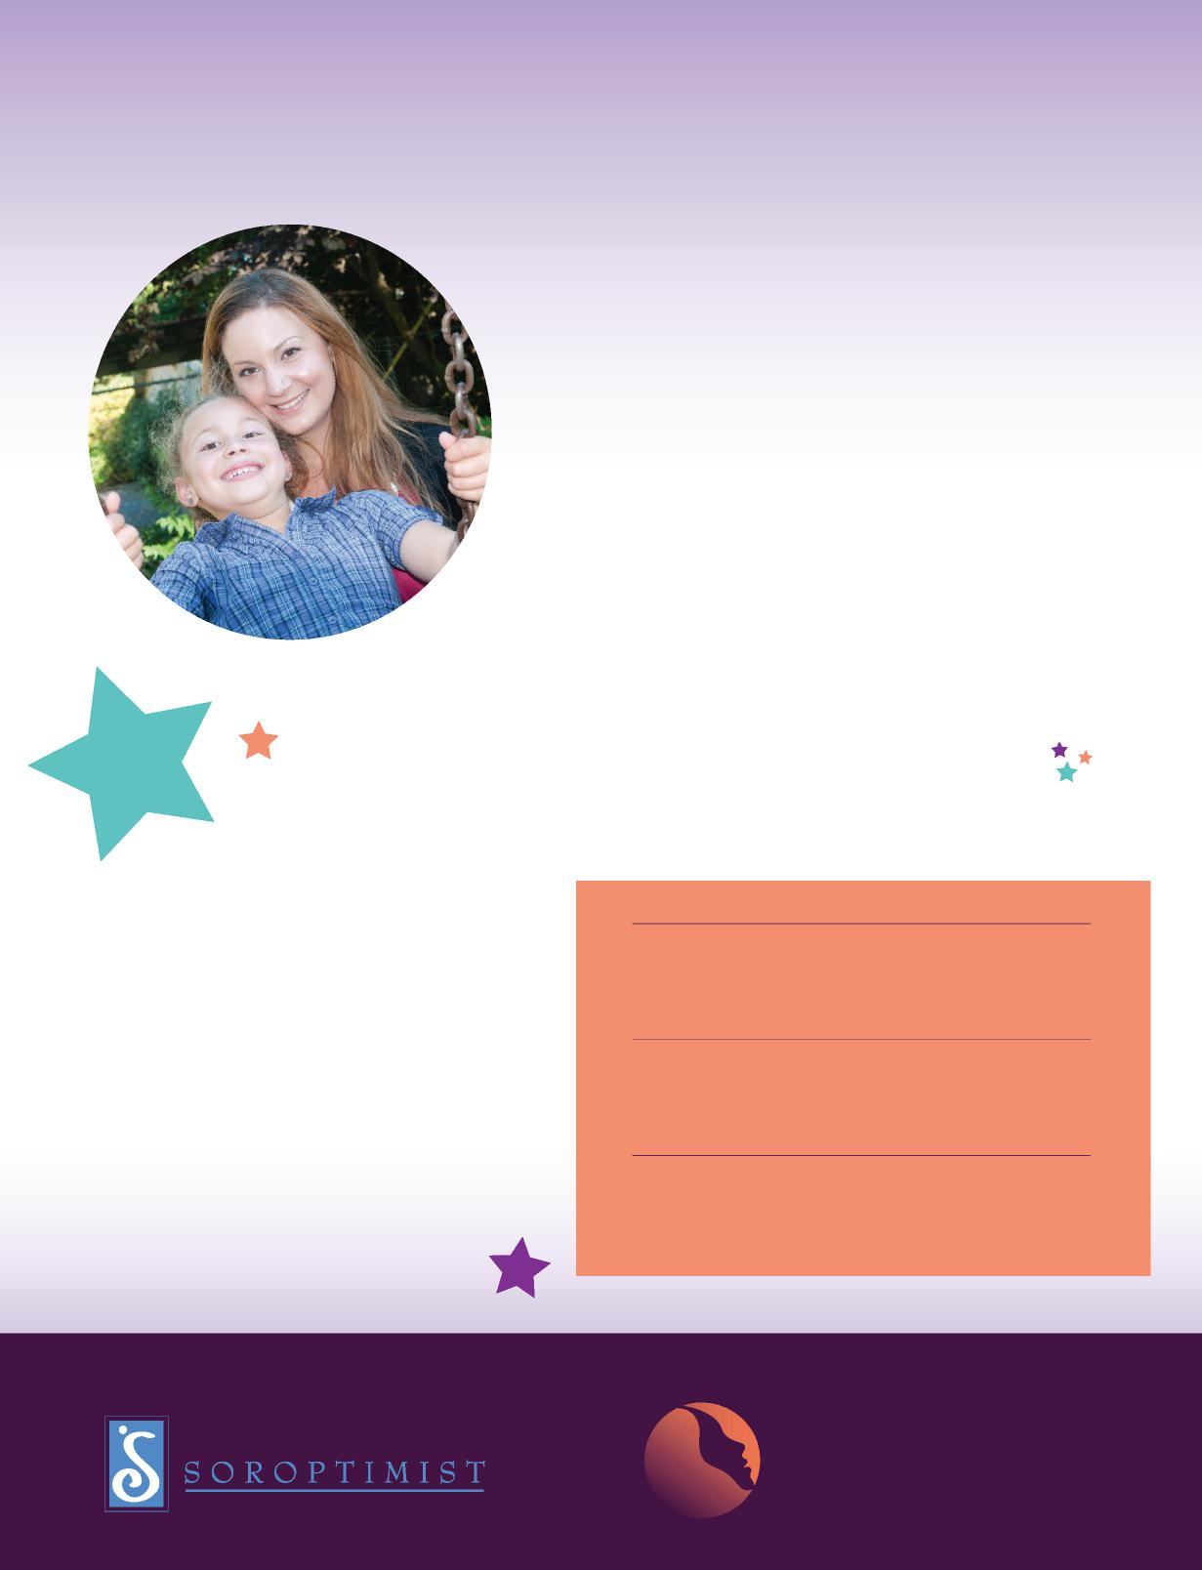
®
powered by volunteers of
empowered by activists of
LIVEYOURDREAM.ORG
Ready to begin a new life?
Since 1972, the Soroptimist Live Your Dream Awards program (formerly the Women’s Opportunity Awards) has disbursed more than $30 million to tens of thousands of women who have overcome poverty, domestic and sexual violence, divorce, the death of a spouse, or other life challenges. They are women— just like you—who had the courage and determination to turn their lives around.
live
Recipients may use the cash award to offset any costs associated with their efforts to attain higher education, including books, childcare and transportation. The program begins on the club level, where award amounts vary. Club recipients become eligible to receive region-level awards, which are granted through Soroptimist’s 28 geographic regions. Currently, each Soroptimist
region grants one first-place award for $5,000.
education & training awards for women
Most regions grant additional $3,000 awards. The
first-place recipients then become eligible for one
of three $10,000 finalist awards.
Soroptimist also offers awards through its
headquarters office to applicants who do not live
within the territorial limits of a Soroptimist club.
Each year about $1.7 million is awarded through
the Soroptimist Live Your Dream
Awards program.

live  YOUR  Dream  education & training awards for women | Instructions

Formerly the Soroptimist Women’s Opportunity Awards
Deadline: Applications are due each year by December 17. Award recipients will be notified between January and June. Not all applicants will be selected for awards. Applications can only be submitted to one club. Your application will be reviewed by a panel of judges, but all information will remain confidential and will not be shared without your prior permission.
Step 1: Determine if you are eligible
You are eligible if you are a woman who:
- Provides the primary financial support for yourself and your dependents. Dependents can include children, spouse, partner, siblings and/or parents.
- Has financial need.
- Is enrolled in or has been accepted to a vocational/skills training program or an undergraduate degree program.
- Is motivated to achieve your education and career goals.
- Resides in one of Soroptimist International of the Americas’ member countries/territories (Argentina, Bolivia, Brazil, Canada, Chile, Colombia, Ecuador, Guam, Japan, Korea, Mexico, Northern Mariana Islands, Panama, Paraguay, Peru, Philippines, Puerto Rico, Taiwan, United States of America, Venezuela).
- Has not previously been the recipient of a Soroptimist Women’s Opportunity or Live Your Dream Award.
- Does not have a graduate degree.
- Is not a Soroptimist member, an employee of Soroptimist International of the Americas or immediate family of either.
- Has a Social Security number or Tax ID number. (This is required for tax purposes and is only necessary if you are a resident of the United States. You will not be asked to share this information unless you have been given an award.)
Step 2: Tell us about yourself
Fill out the award application telling us about yourself. Your information will be kept confidential and shared only with the evaluators unless you give us written permission to use your story to publicize the program. **You must use Adobe Reader (free to download) to fill out the form. If you do not use Adobe Reader, your answers in the application will not be saved and your submitted application will appear blank.**
- Step 1: Download Adobe Reader.
- Step 2: Save a copy of the application to your computer.
- Step 3: Open Adobe Reader.
- Step 4: From the left column, choose ‘My Computer’ and find where you saved the application.
- Step 5: Open the application within Adobe Reader.
- Step 6: Hold your mouse over the first blue text box and click.
- Step 7: Type your responses into the application. (Note: You will not be able to change the type size. Please limit your answers to the space allotted.)
- Step 8: Once all parts of the form are completed, select “File” and choose “Save As” from the drop down menu.
- Step 9: Change the file name (for example, “LYDApplication-(your name)
- Step 10: Click “Save.”
- Step 11: Submit.
Step 3: Ask people to tell us about you
You will need two different people—who are not related to you—to fill out the reference forms you received with this application. It is recommended that you request references from people who know you from an education or work setting. Please email this form to your references and request they email the forms back to you when completed. Only two references will be accepted. Please use the form and do not submit reference letters.
Step 4: Submit your application
Attach your application and two reference forms to an email and send to the contact person listed below by November 15. Incomplete applications or applications received without reference forms will not be considered.
Soroptimist Club Name: Soroptimist International of Chino Hills/Inland Empire
Region: Golden West Region
Club Contact Person: Lorraine Morris
Telephone: 909.223.2687 Email Address: sichinohills.inlandempire@soroptimist.net
Address: PO Box 2998
City: Chino Hills State: CA Postal Code:091709
Questions
Check out the Live Your Dream Award Frequently Asked Questions at http://www.Soroptimist.org/awards/DreamAwardsFAQforApplicants.pdf. If you still have questions, contact the person listed above or Soroptimist headquarters at siahq@soroptimist.org.
Ready to Apply?
Begin your application on the next page now! We wish you the best of luck in achieving your educational and professional goals.
Start Your Application Now!

Ready, Set, Live Your Dream!
Begin your application now.
Part I. Basic Information
Name (first, middle initial, last):
Address (number and street address):
City/Province: State:
Postal Code: Country:
Telephone: Email Address:
Date of Birth: Marital Status:
Highest level of education achieved: Date Completed :
Number of dependents you support (NOT including yourself):
How are they related to you (children, spouse, parents, etc.)?:
Ages (if they are children):
Part II. What are your education and career goals?
- What’s the name of the school or training program you are attending or have been accepted to?
- What are you studying? (example: Bachelor of Science nursing degree or computer science certificate)
- When will you complete your studies (month and year)?
- Are you working while you are getting your education? (check one) YES NO
If yes, how many hours per week?
- In 300 words or less, please tell us about your career goals, and give specifics about how your education and training supports these goals.

Part III. Financial Information

Please list any additional expenses.
Expense: $ per year
Expense: $ per year
Expense: $ per year
per year per year per year per year
per year per year per year per year

Housing: | $
Food: | $
Childcare: | $
Tuition: | $

Utilities: | $
Medical: | $
Transportation: | $
Books: | $

Live Your Dream Award recipients are chosen in part based on financial need. Please share information about your annual income and expenses. Please be as exact as you can.
- INCOME: Please list your ANNUAL household income and savings (from the money you have left after taxes) in the chart below.

Employment: | $ | per year | Government Assistance: $ | per year
Savings: | $ | per year | Social Security (U.S. only): $ | per year
Child Support: | $ | per year | Loans: $ | per year
Alimony: | $ | per year | Scholarships: $ | per year

Please list any additional income, including income other household members receive.
Source: $ per year
Source: $ per year
Source: $ per year
TOTAL ANNUAL INCOME:
- EXPENSES: Please list your ANNUAL household expenses in the chart below.
TOTAL ANNUAL EXPENSES:

Part IV. Tell us more about yourself
The Live Your Dream Award is all about helping women who have faced economic and personal hardships to live their dreams. Since 1972, the award has provided tens of thousands of women with cash grants to help them achieve their educational and career goals. The program helps women build a better life for themselves and their dependents. Do you think this award could help you live your dream? In 750 words or less, tell us about the challenges you’ve faced and how you think this award could help you to live your dream.

Part V. Agreement
Please read the following information carefully. When you type your name below, you are agreeing to what you have read.
- I certify that all the information provided in this application is complete and accurate to the best of my knowledge. I will notify Soroptimist if there are any changes.
- I understand this award is not a scholarship and is therefore taxable for citizens of the United States. (For more information, consult IRS publication 520. Residents of other countries should check their local tax laws.)
- I certify that this is the only application I have made—in any format or to any address—this year for a Soroptimist Live Your Dream Award.
- I understand that my application may be submitted electronically for evaluation.
- I understand that my application becomes the property of Soroptimist International of the Americas. The application will be considered confidential unless the applicant grants Soroptimist written permission to release personal information for the purpose of publicizing the award.
By typing your name below, you adhere to the above requirements.
Signature of applicant Date
Thank you for applying for the
Live Your Dream Award.
Congratulations on all you have achieved so far!

Soroptimist International of the Americas
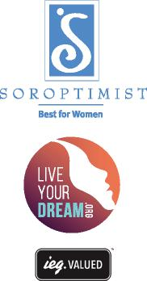
®
1709 Spruce Street
Philadelphia, PA 19103-6103 215-893-9000 www.Soroptimist.org www.LiveYourDream.org

